IOT Enabled Sensor Based Sanitization System

Internship project

**Submitted to:-**

**DEI-Butterflyfields**

**Under the guidance:-**

*Dr. R. S. Pavithr*

*Mr. Amarjeet Singh Chauhan*

**Submitted by:**

**Tinkal shakya**

DEPARTMENT OF PHYSICS & COMPUTER SCIENCE FACULTY OF SCIENCE

DAYALBAGH EDUCATIONAL INSTITUTE DAYALBAGH AGRA(UP)-282005

**CERTIFICATE**

This is to certify that the dissertation entitled **IOT Enabled Sensor Based Sanitization System** submitted by **Abhishek Singhal , Arpit kr. Jain, Adil Ansari, Dayal Nigam , Hritik and Tinkal Shakya** in partial fulfillment the requirements for the award of degree of *Bachelor of vocation* to the Dayalbagh Educational Institute, Dayalbagh, Agra, is a record of his own work carried out under my supervision. The matter embodied in this project has not been submitted for the award of any other degree.

**Dr. R.S. PAVITHR**

**Supervisor**

**Dept. of Physics and Computer Science Faculty of Science Dayalbagh Educational Institute (Deemed University)**

**DECLARATION**

We solemnly confirm that the report entitled **IOT Enabled Sensor Based Sanitization System** embodies an original work carried out by us and has not been submitted, either in part or full, to this or any other University/Institute for the award of any other degree*.*

**AbhishekSinghal Arpit kr. Jain Adil Ansari Dayal Nigam Tinkal Shakya**

**ACKNOWLEDGEMENT**

It gives me immense pleasure to express my deepest sense of gratitude and sincere thanks to my highly respected and esteemed **Mrs. Laxmi Rau Vadapalli** guide for her valuable guidance, encouragement and help for completing this work. His useful suggestions for this whole work and co-operative behaviour are sincerely acknowledged.

I am grateful to my teachers for their constant support and guiding. I am very thankful to **Dr. R. S. Pavithr** and **Mr. Amarjeet Singh Chauhan** for their constant moral support and criticism which prove to be very helpful in completion of this different task.

## INDEX

Contents

ACKNOWLEDGEMENT 6

ABSTRACT 8

Report of Day: 1 9

Report of Day: 2 10

Report of Day: 3 14

Report of Day: 4 17

Report of Day: 5 18

Report of Day: 6 19

Report of Day: 7 21

Report of Day: 8 22

Future Scope 25

Conclusion 26

References 27

ABSTRACT

The Aim of this task to create a small smart and low cost hand sanitization system using node-mcu and display the sensor data on the dashboard which is mainly a django based or firebase based. Basically the whole idea is to implement the concept on hand sanitizer to make it so smart that when the bottle gets empty it automatically sends an email to the concern person to refill the bottle so we have used node–mcu for sending the sensor data over the server.

# Report of Day: 1

1. We have started work with the dashboard since we find this to complete first in our project.
2. We start collecting the information about creating an secure dashboard so we create the dashboard on firebase which is more secure to display data.
3. Also we used register & sign method for displaying the data to more secure method.

## Firebase configuration:-

* 1. Go to the firebase home page

<https://console.firebase.google.com/u/0/>

* 1. Create the new project inside it.

# Report of Day: 2

1. **Firebase:-**

1. 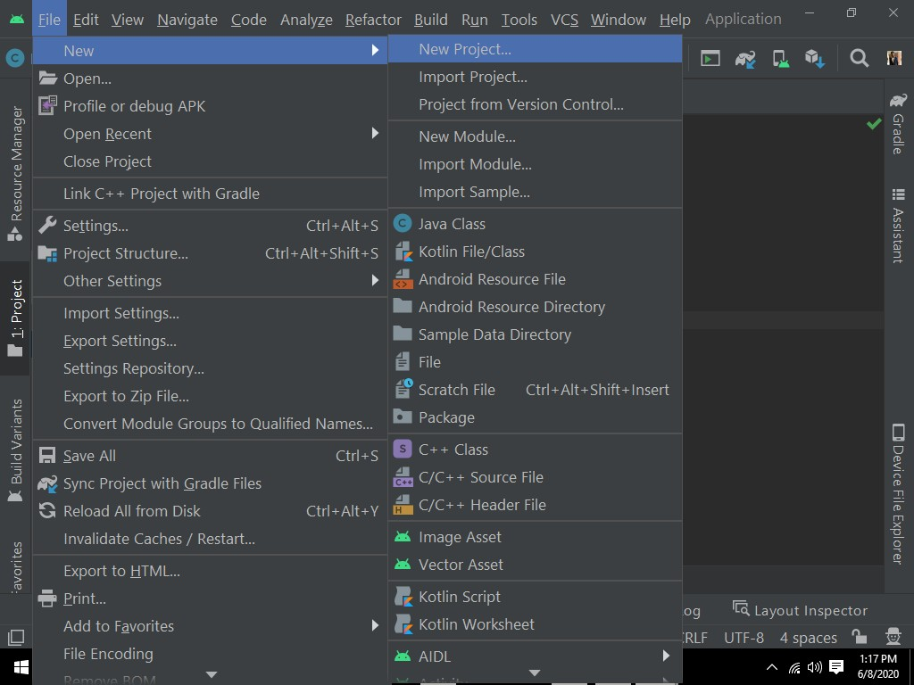Open the Android studio start new project.
2. After creating the java project.

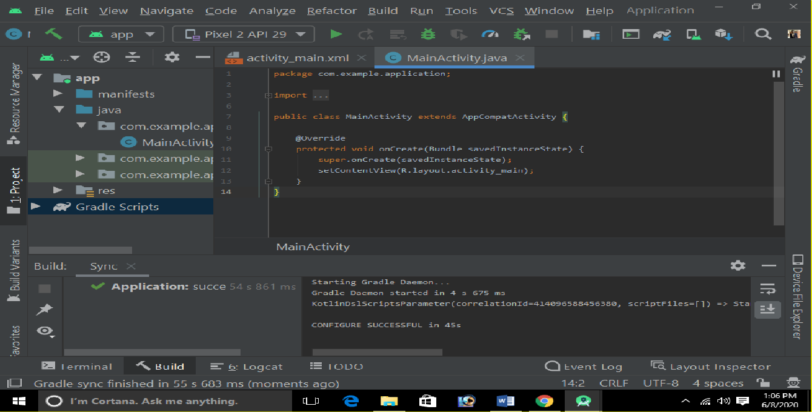

1. 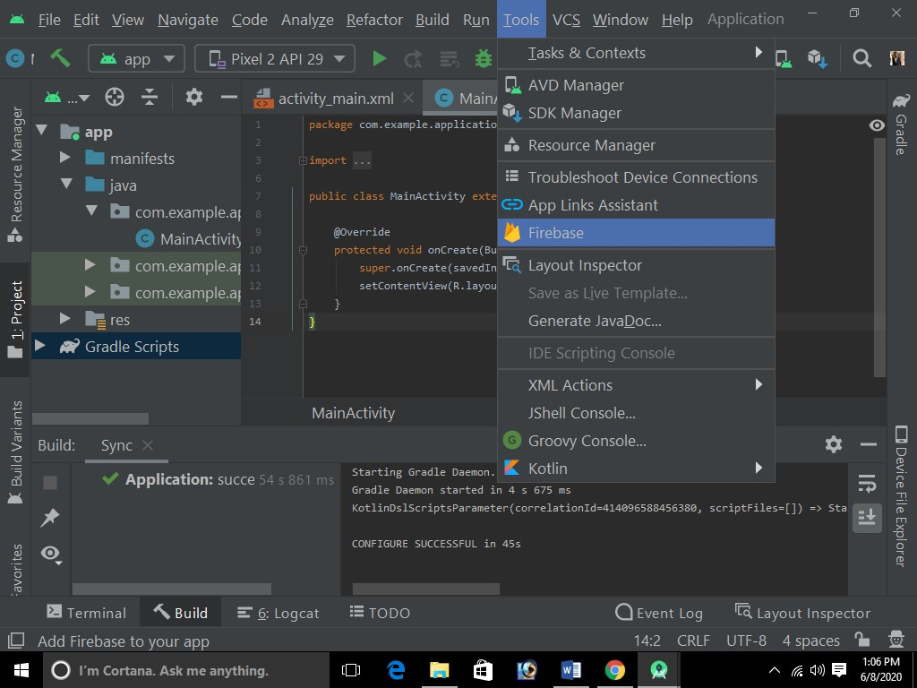Once the sync is successful.
2. 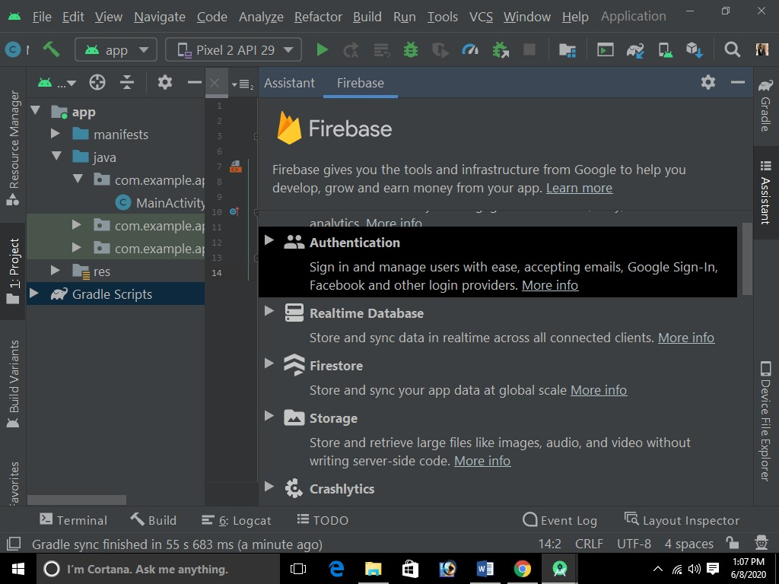Go to the tools->firebase.
3. 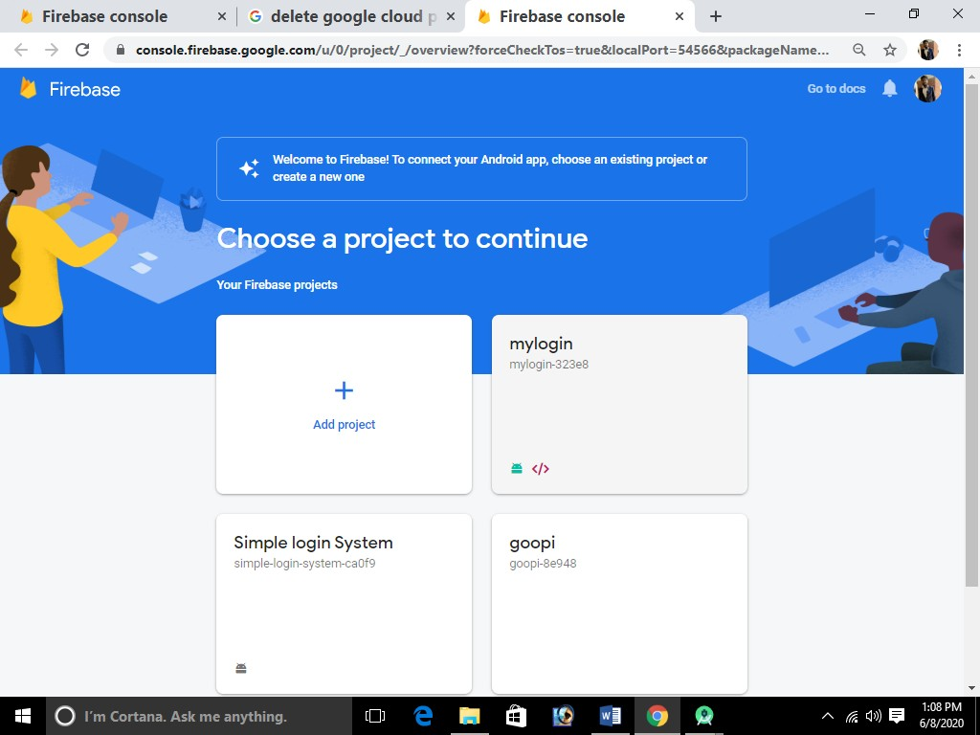Connect the firebase with the project.

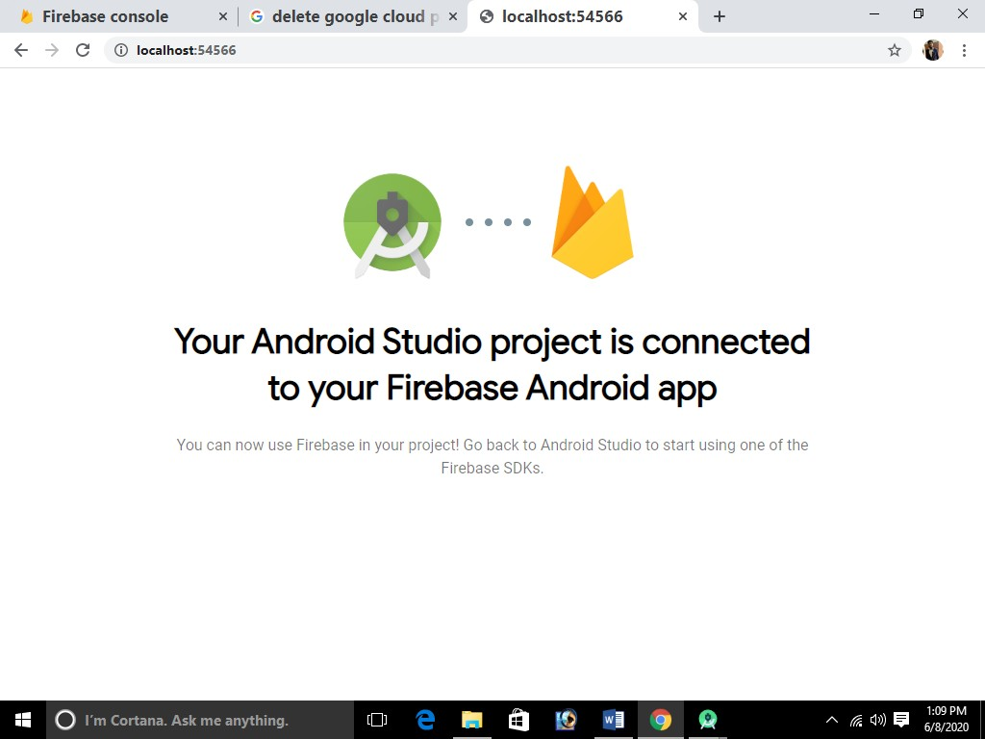

1. 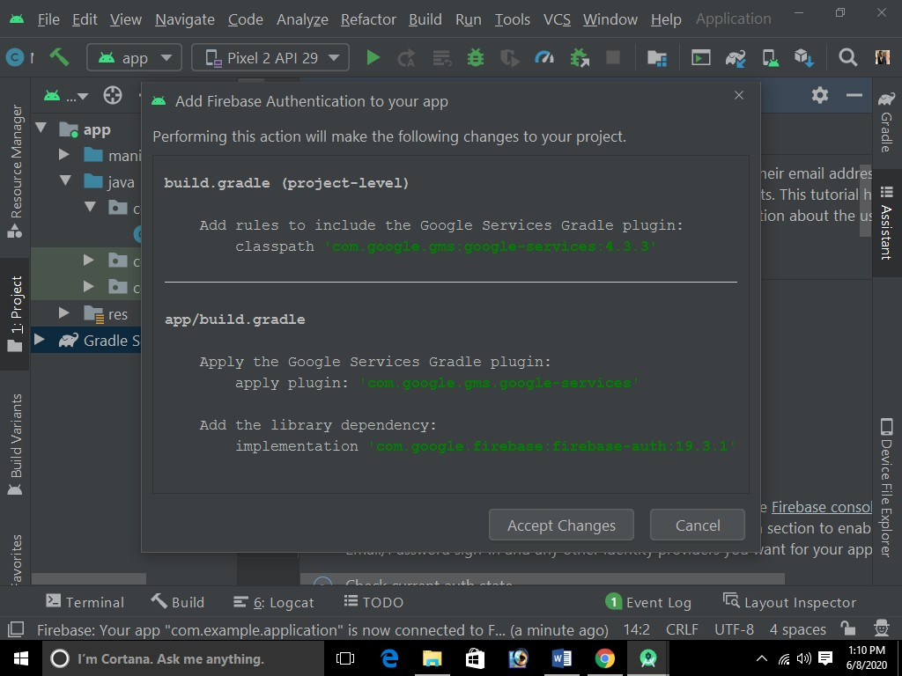Once the Android project gets connected.

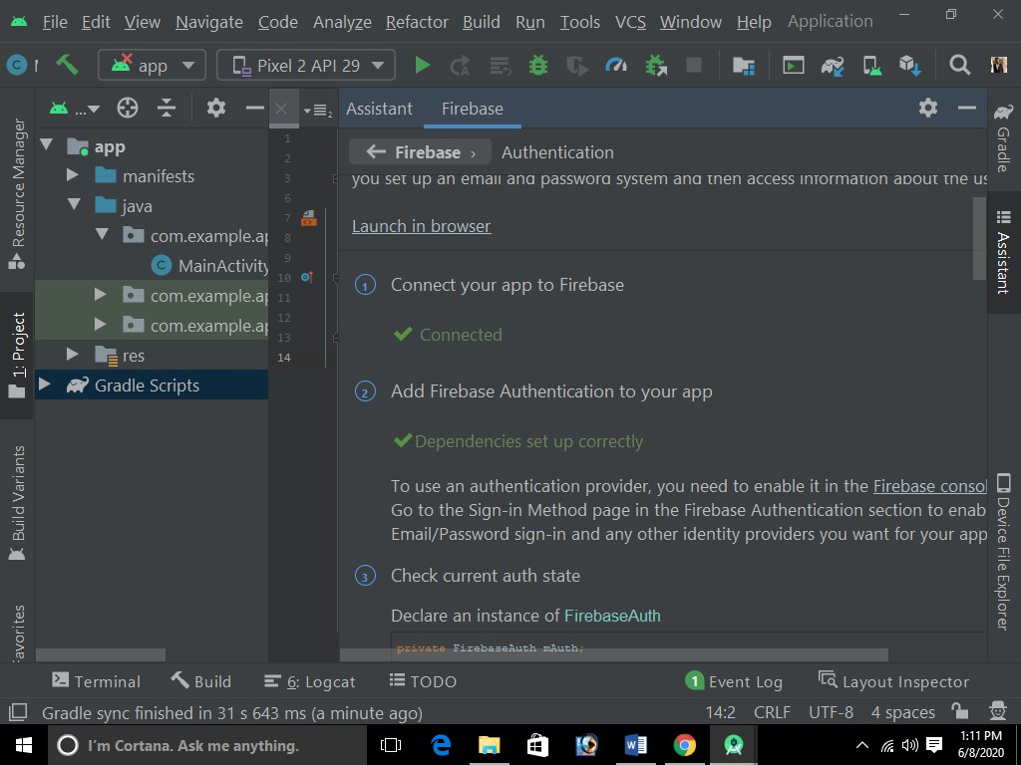

# Report of Day: 3

## Firebase:-

* 1. Start creating the project by adding the google- services.json file in the project.

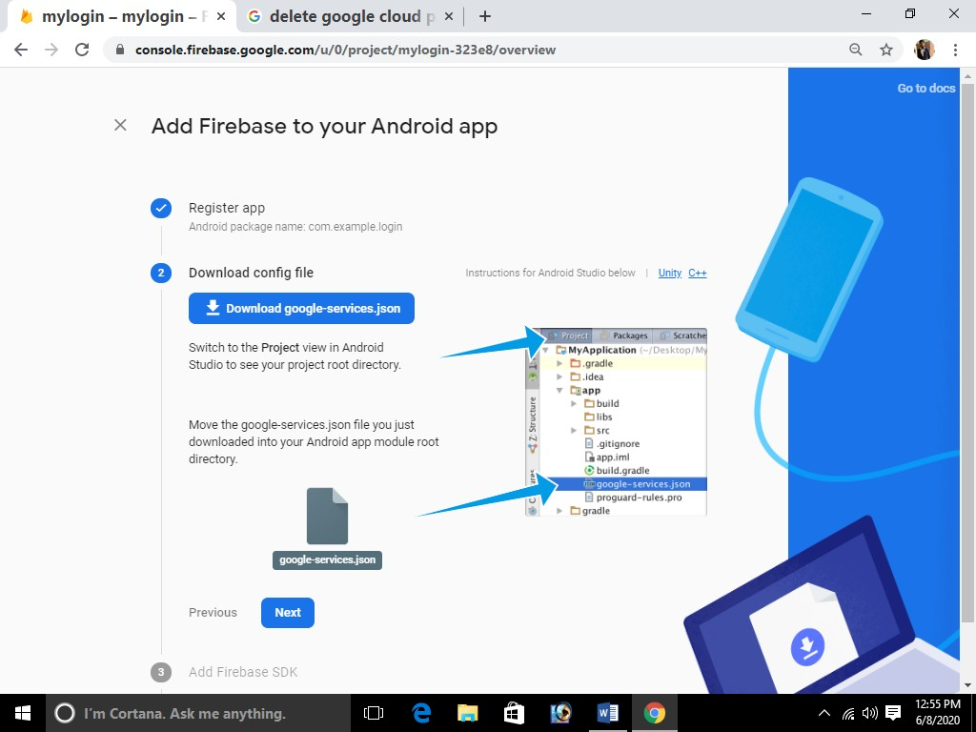

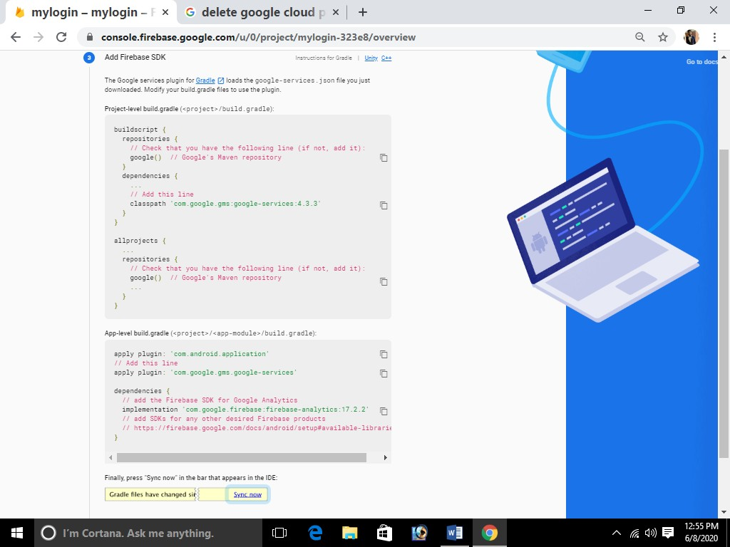

* 1. **LAYOUTS:-**

**We have created three layouts**

* + 1. 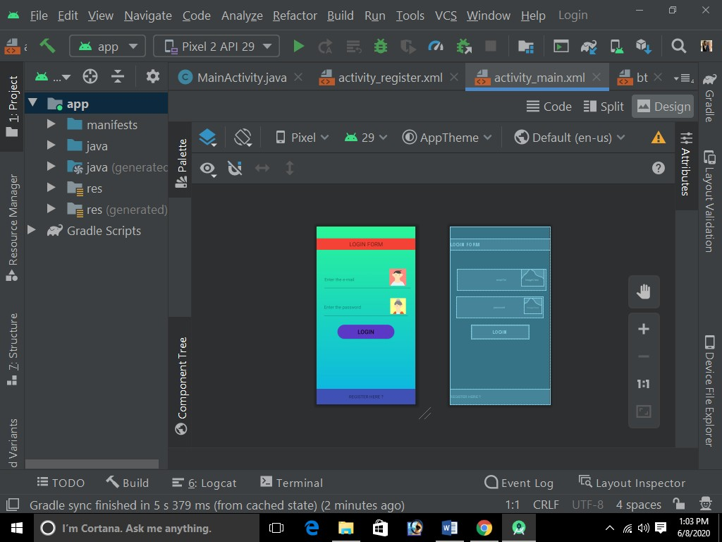**Login activity:-**
    2. **Register activity:-**

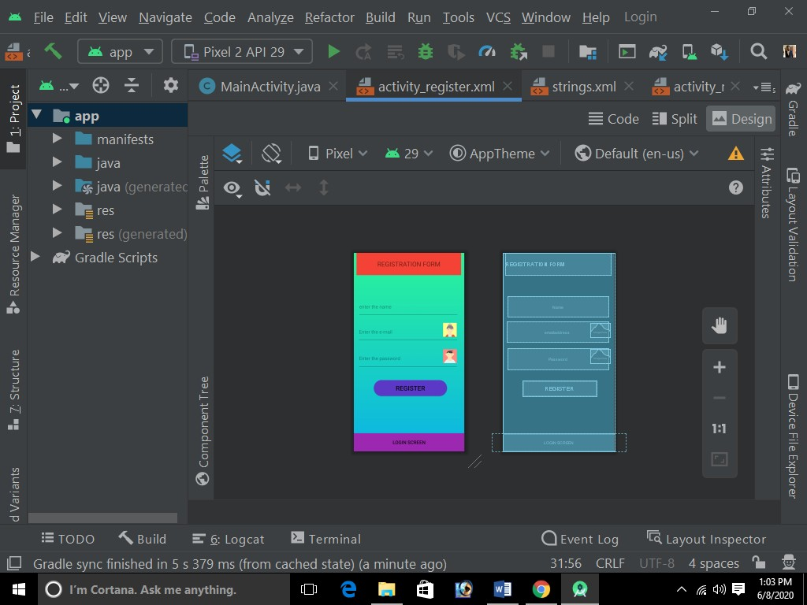

* + 1. 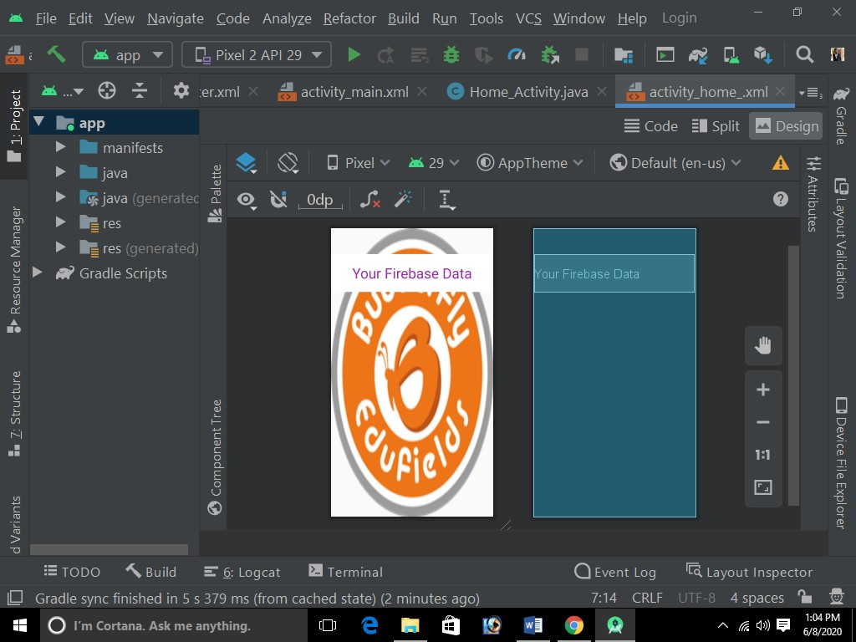**Home activity:-**

# Report of Day: 4

1. 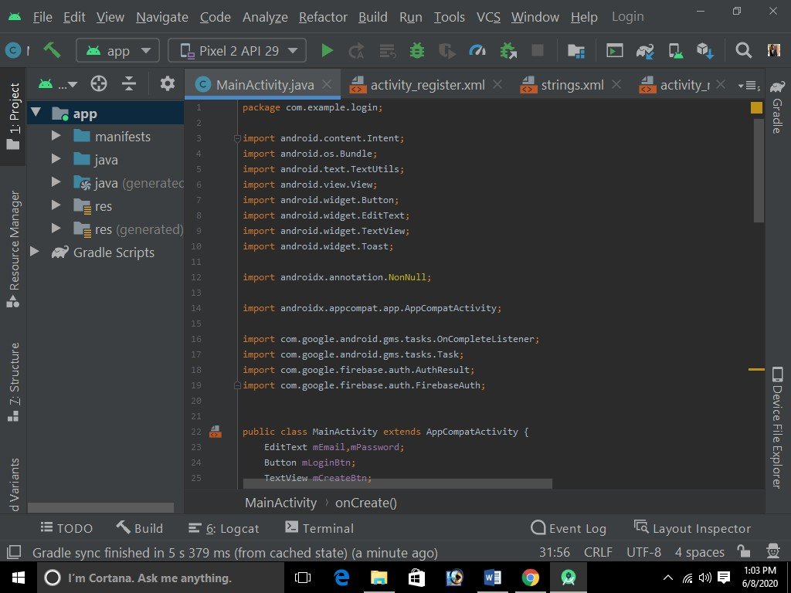CODE SNIPPETS:-
2. Verifying whether the code is sending the credentials to firebase or not

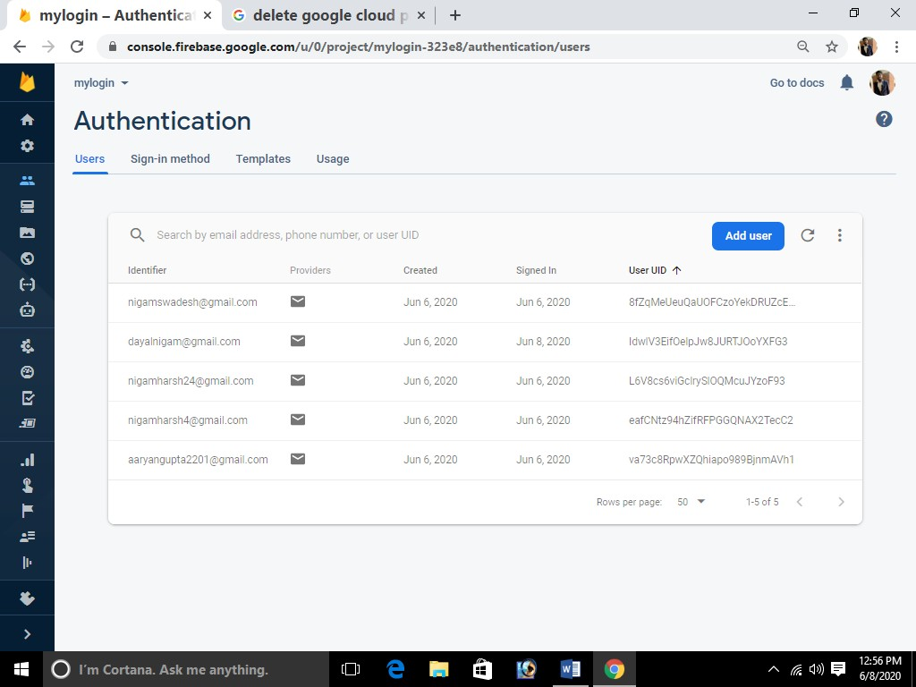

1. The App has been running successfully.

# Report of Day: 5

1. Setting up the code for Nodemcu(ESP8266- 12E).

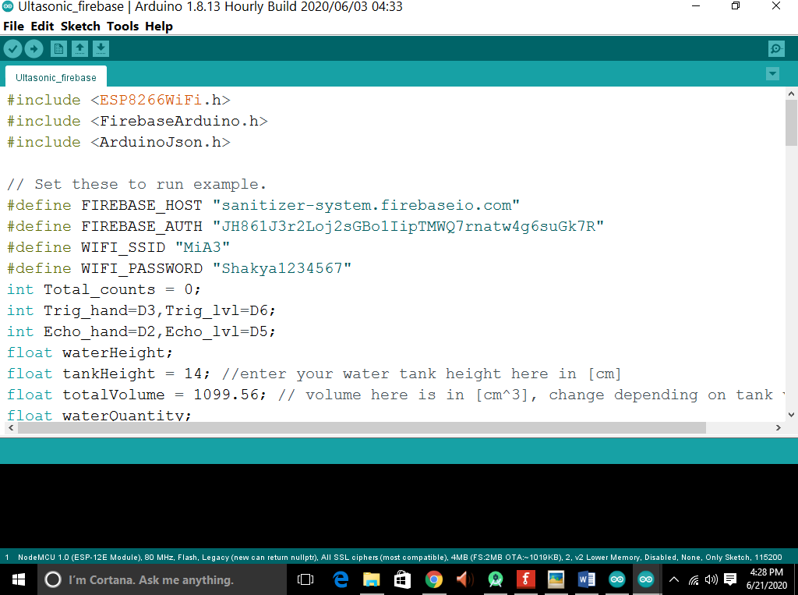Software Part

Code :- [https://drive.google.com/file/d/1dnzb2aDUsEDtLnA4_](https://drive.google.com/file/d/1dnzb2aDUsEDtLnA4_1sqPJ6BFoBjOXvB/view?usp=sharing) [1sqPJ6BFoBjOXvB/view?usp=sharing](https://drive.google.com/file/d/1dnzb2aDUsEDtLnA4_1sqPJ6BFoBjOXvB/view?usp=sharing)

# Report of Day: 6

1. Setting up the necessary hardware for the project

Hardware Part

1. 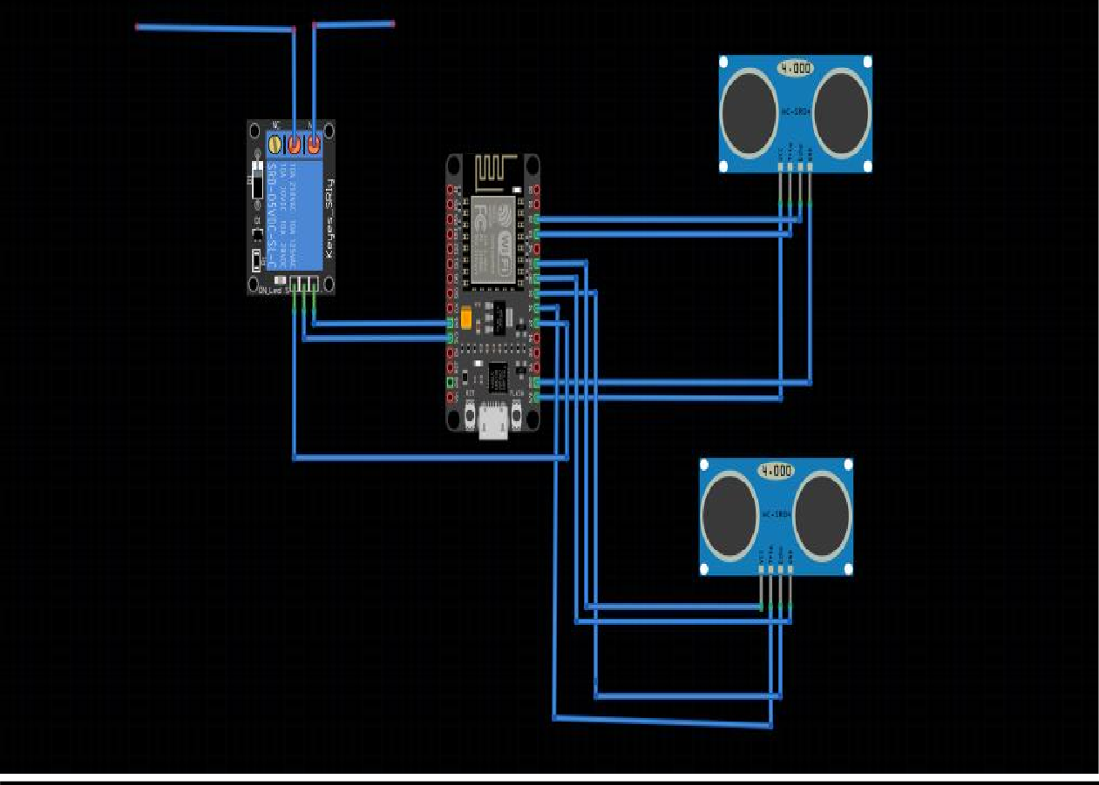Circuit Diagram
2. The end points of the relay are connected to the battery & motor for controlling the circuit.
3. Ultrasonic sensor-1

Trig-D3(connected to nodemcu) Echo-D2(connected to nodemcu)

1. Ultrasonic sensor-2

Trig-D6(connected to nodemcu) Echo-D5(connected to nodemcu)

1. Relay

Positive-(nodemcu vcc) Negative-(nodemcu GND) Signal-(nodemcu D7) Realy output

# Report of Day: 7

* + Android Dashboard

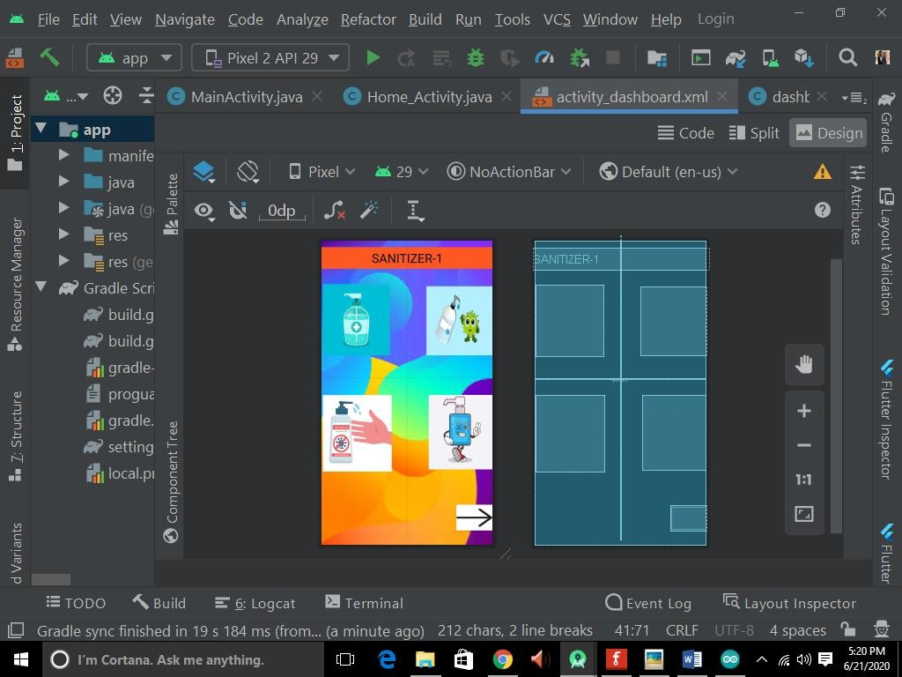

Video for the project:- [https://drive.google.com/file/d/1h9b6hQ0vzOx](https://drive.google.com/file/d/1h9b6hQ0vzOxkDT-6WYO82sMl74sh84oi/view?usp=sharing) [kDT-6WYO82sMl74sh84oi/view?usp=sharing](https://drive.google.com/file/d/1h9b6hQ0vzOxkDT-6WYO82sMl74sh84oi/view?usp=sharing)

# Report of Day: 8

1. 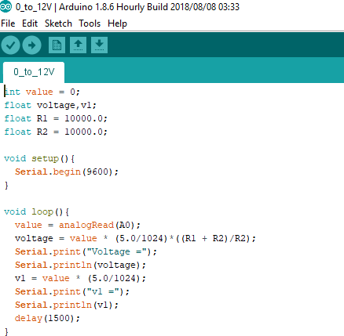Voltage Measurement:-

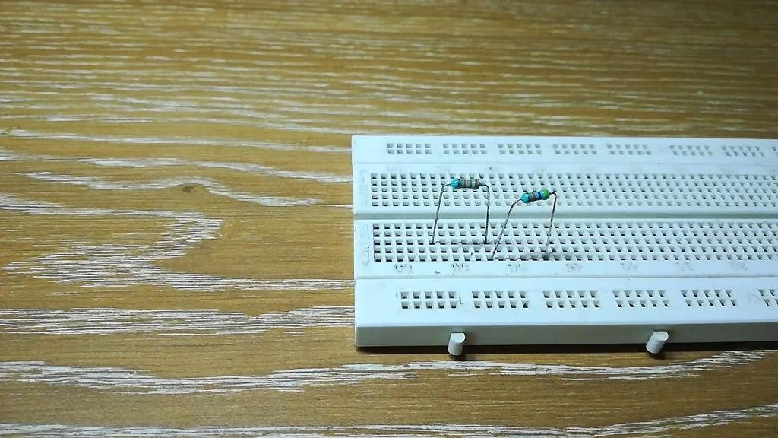

1. Voltage divider Circuit:-
   * In voltage divider circuit we uses resistors in series.
   * Value of resistor depends upon maximum voltage of the battery.

For voltage measurement we have two approaches:

* Direct read from analog pin
  + Reliable when maximum voltage is less than 3.3v
* Through voltage divider circuit
  + Reliable when maximum voltage is more than 3.3v

1. 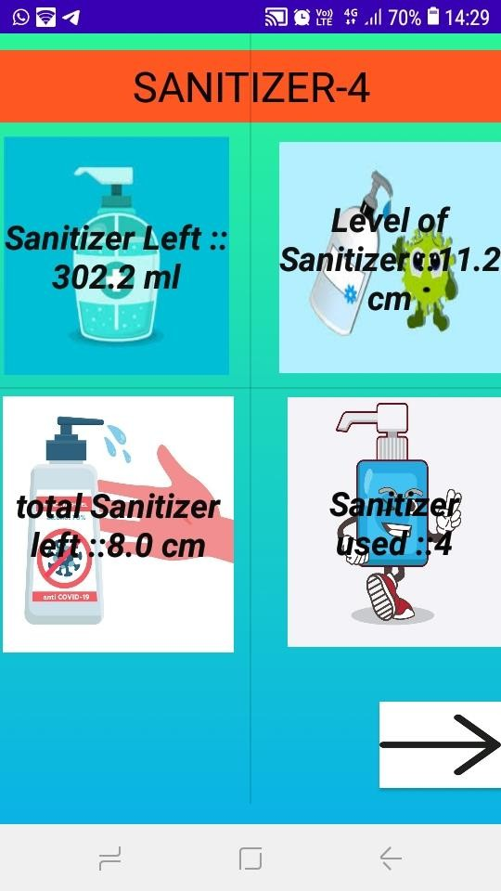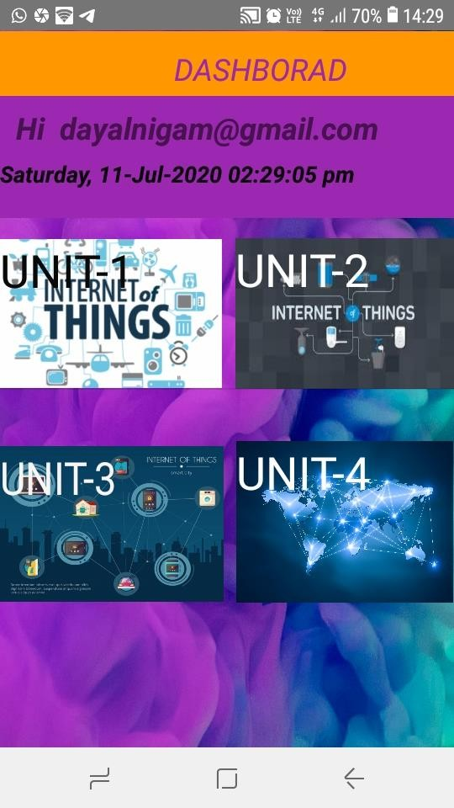Screen-shots of our App:-

# Future Scope

* + This project is really important in such pandemic conditions like coronavirus.
  + It has a huge scope in future since due to corona people start take care of the cleanliness so it has a huge future scope.
  + Also we can make body sanitizers also after this so that full body gets sanitize.

# Conclusion

This **internship** has been an excellent and rewarding experience. I can **conclude** that there have been a lot I've learnt from my work at ButterflyEduFields. Also the project which we have create is so interesting since it is now used in this pandemic condition of coronavirus. Also I have learnt that how to work in team like professionals.

# References

* + Iotianhub
  + ButterflyEduFields
  + Firebase documentation